
American Time Radio Controlled/Quartz Clock

Operating Instructions:

Step 1: Verify hands are exactly at the 12:00 position.
If hands have moved during shipping see “Positioning Hands”.
Step 2: Move the slide switch on the movement to match your local time zone.
- P – Pacific Time
- M – Mountain Time
- C – Central Time
- E – Eastern Time
Step 3: Remove the red pin.
Step 4: Insert a fresh “AA” alkaline battery.
That’s it! Clock will automatically reset to the correct time, if signal is available in your area.

IMPORTANT: Read all instructions before running any clocks!!

ABOUT YOUR RADIO CONTROLLED CLOCK:
Your radio controlled clock movement is equipped with circuitry and a receiver to pick up a (60 kHz) time signal (WWVB) transmitted by the National Institute of Standards and Technology (NIST) from Fort Collins, Colorado. The time signal is based on a Cesium clock, one of the most accurate timekeeping devices in the world. Your clock will automatically compare the time signal received to the time on the clock. Once your clock sets itself it will continue to automatically synchronize every day (8X).

At startup the sweep will fast run one minute and the hour and minute advance 12 hours and stop at 12:00. After the hands stop the clock will try to receive the time signal (3 – 15 minutes) and if the time signal is received the clock will set (4 minutes). If no signal is received after 15 minutes the clock will start running from the 12:00 position and continue to check for the signal an hour later.

It is recommended upon receiving your clocks to start them all in one room, preferably an outside room that faces Fort Collins, Colorado. Signal strength will be best here and will allow you to see if the clocks are working properly before installing in their designated spots. Re-start clocks in designated spots and if you have locations where the signal is very poor your clock may be set manually, see “Manual Time Setting”.

Do not remove the crystal and move the hands manually. This will change the reference position of the hands to the gears and the time will not be right even if the clock corrects. If this occurs, go through the “Setting/Verifying the 12:00 Position” to re-align the hands.

If problems occur with your clock refer to the “Radio Control Troubleshooting Guide” section of the instructions.

Positioning Hands: Perform steps 1 thru 3 in “Setting/Verifying the 12:00 Position” before doing this step, unless it is a new clock and/or the red pin is still inserted.
1. Hold the clock case with your hands at the 03:00 and 09:00 position.
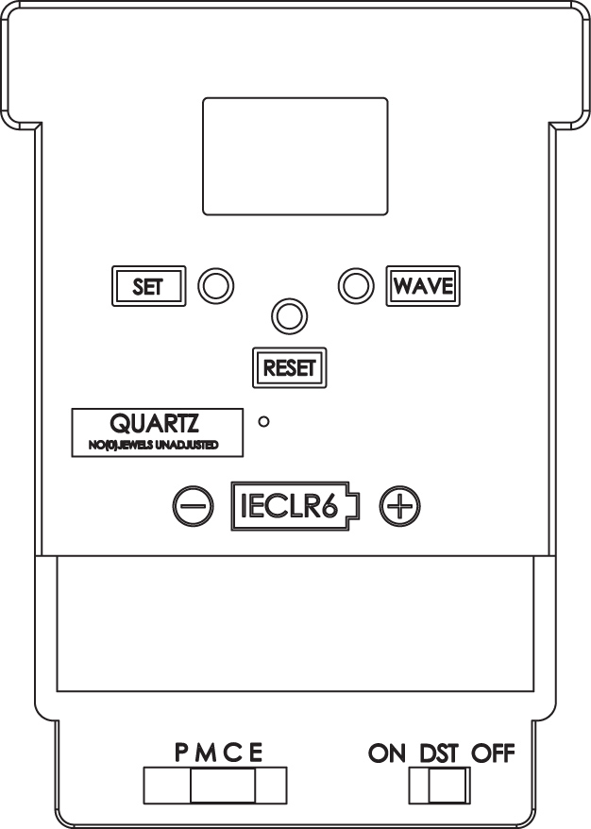
2. Squeeze the clock case together and the lens will pop out.
3. Pull hands straight off.
4. Re-align the hour, minute and sweep hands to the 12:00 position.
5. Replace the lens by popping the tabs on the crystal into the holes on the bezel.
6. Pull the red pin, verify the time zone is set correctly and install the battery to restart.

Setting/Verifying the 12:00 position:
1. While the clock is running push the RESET button on the back of the movement.
2. Hands will run to 12:00 and stop, replace red pin, remove battery.
3. If hands are off, remove & re-position, see “Positioning Hands”.
4. If hands are on 12:00, hand position is o.k.
5. Pull red pin, verify time zone is set correctly and install battery to restart.

Manual Time Setting:
1. Hold the SET button on the back of the movement for 3+ seconds to activate manual mode.
2. Once the clock is in manual mode press the “SET” button to adjust time. Press and release immediately to advance one minute, press and hold and hands will rapid advance. Release button a minute or two before desired time & then press and release “SET” button to advance to the exact time.
3. The clock will automatically leave manual mode after the SET button is not pressed for 6+ seconds.
The clock has been set manually and the timekeeping function will be controlled by the movement’s microprocessor. The movement will attempt signal reception after being set manually and if successful will automatically correct.

Daylight Saving Time Bypass

If you are in a time zone that does not follow DST move the DST switch to the OFF position.

Wave (Forced Signal Reception)
The WAVE button can be used to force signal reception. To activate, hold the WAVE button down for 3+ seconds. Once the WAVE feature is activated, the hands will automatically reset to the 12:00 position and the movement will attempt to receive the WWVB signal from Fort Collins, CO. If the movement successfully receives the signal, the clock will reset automatically to the correct time. Generally, reception of the WWVB signal takes approximately 3-15 minutes. If the clock still fails to receive the signal while in the WAVE mode, the clock will automatically leave the WAVE mode. In this case, set the clock manually, see “Manual Time Setting” above.

Radio Control Troubleshooting Guide
Symptom | Problem | Resolution
Hands don’t move | Normal startup  Battery in wrong  Dead battery | Hands will run to 12:00 upon startup and then stay at 12:00 while searching for a signal. The search procedure takes approximately 3 to 15 minutes after all hands have set to the 12:00 position.  Verify battery is in correctly  Replace with new battery
Doesn’t correct | At initial startup  Poor reception  Hasn’t found signal  Geographical location  Signal interference  Bad weather conditions  No reception | Hands will run to 12:00 upon startup and then stay at 12:00 while searching for a signal. If the clock does not receive a radio signal soon after activated, the clock will start running from the 12:00 position and will continue to run. In this case, do not attempt to reset the hands manually even though the time displayed is incorrect. The clock is synchronizing to the WWVB signal and once the radio signal is decoded, the hands will automatically adjust to the correct time.  Move to a different location. May not pick up signal in rooms in the middle of large buildings or on lower levels  Wait at least 72 hours  Set clock manually, see “Manual Time Setting” section  Move clock several feet from electronic appliances, electrical or metal appliances, large metal surfaces or objects  Hospital equipment may interfere with signal, move or set time manually.  Wait until conditions are better and re-try  Set clock manually, see “Manual Time Setting” section
Sweep/second hand vibrates but doesn’t move | Sweep/second hand sticks at around the 08:00 to 09:00 position and vibrates | Check/replace battery, voltage cannot be below 1.25V
Sweep/second hand stops at 01:00, 03:00 and 06:00 AM | Normal synchronization process | 01:00, 03:00 and 06:00 AM are radio signal reception times and at these times the sweep/second hand will stop, signaling a signal reception time. At the end of the reception time (3-4 minutes) the clock will correct if necessary and the sweep hand will resume movement.
Time is off | Hands moved during shipping  Hands physically moved  Wrong time zone  No signal reception at initial startup | Verify hand position by running clock to the 12:00 position. If hands are off, re-position hands, see “Setting/Verifying the 12:00 position”.  Hands cannot be manually rotated with your fingers. Verify hand position by running clock to the 12:00 position; see ”Setting/Verifying the 12:00 position”. If hands are off, re-position hands, see ”Positioning Hands”.  Set slide switches to appropriate time zone and DST setting.  At initial startup, hands will fast advance to 12:00 and then stay at 12:00 while searching for a signal. If the clock does not receive a radio signal soon after activated (within 15 minutes), the clock will start running from the 12:00 position and will continue to run but will not be on the correct time. See the “Doesn’t Correct” section above.
Clock noise | Clock is setting or readjusting itself | Allow to reset
Losing or gaining time | Low battery  Hands loose  Hands rubbing each other, dial or crystal  Picking up interference | Replace battery, voltage cannot be below 1.25V  Run clock to 12:00 position, see ”Setting/Verifying the 12:00  Remove battery, adjust hands, then run to the 12:00 position to verify hands, see ”Setting/Verifying the 12:00 position”  Move clock to a new location

REVISION HISTORY

Revision | CR Number | Description of Change | Effective Date
1 | 2031 | Initial Release | 04-08-11
2 |  | Change to new Logo
3 | NA | Changed troubleshooting for Time is off/Wrong time zone from rotary switch to slide switch and added “DST setting”. | 11-3-16

